

Student Workbook

3.H.17 Ailments of the Digestive System

Student Name: ……………………………………………………………

Student Number: ………………………………………………………….

Email: ………………………………………………………………………

Phone: ……………………………………………………………………..

Other Personal Information

www.OnlineHorseCollege.com
(Ausintec Academy P/L ATF Ausintec Academy Trust T/as)
Ausintec Academy

Mailing Address:-
392 Bribie Island Road,
CABOOLTURE QLD 4510
(between Brisbane & Sunshine Coast)
AUSTRALIA
Registered Training Organisation No:31352
Centrelink Approval No: 4P530
CRICOS Provider Code: Pending

Phone within Australia (07) 3102 5498
Outside Australia + 61 7 3102 5498
Request@OnlineHorseCollege.com

Contents

Unit Information Pg. 4
Ailments of the Digestive System Introduction Pg. 5
Colic Pg. 6 & 7
Botulism Pg. 8
Enteritis Pg. 9
Colitis X Pg. 10
Extension Lesson Pg. 11
Recommended Reading Pg. 12
References Pg. 13

Ailments of the Digestive System 3.H.17 Workbook

Students are to complete Horse Care 3.H.13-16 online assessments prior to attempting Horse Care 3.H.17-20 and to follow all recommended safety considerations.

Practical assessments for Horse Care 3.H.17-20 are as follows:
- Ailments of the Digestive System

- Ailments of the Respiratory System

- Ailments of the Circulatory System

- Therapies

These assessments incorporate the following unit from the SIS30710 Sport Industry Training Package which include the listed elements

RGRPSH401A Relate anatomical and physiological features to the care and treatment of horses

- Identify basic anatomy and physiology of horses

- Relate anatomy and body systems to the performance of racehorses

- Follow illness and injury management plans

Further information about this assessment is available at www.training.gov.au

Ailments of the Digestive System Introduction

Digestion involves a series of physical, biochemical and biological processes to breakdown food for the extraction of energy and nutrients. The process of digestion (moving food along the digestive tract) is involuntary, that is it is controlled by autonomic processes. Presented in this week are the common ailments that can affect the digestive system of a horse.
As a general rule in the event that a condition or injury does not improve or that the ailment cannot be identified veterinary attention and advice should be sought.
Colic

The term colic is used to describe abdominal pain. Colic can have many causes which affect organs within the abdominal cavity. There are four main categories of colic spasmodic, impactive, gaseous distension and intestinal catastrophe (twisted gut).
Spasmodic
This type of colic occurs most frequently and is a result of spasms of the intestine muscular wall. The usual causes of spasmodic colic are internal parasite larvae that cause damage to the intestinal wall when they migrate and feeding too soon after exercise.
Impactive
As the name suggest this type is caused by impaction of food in the large intestine. It occurs in a narrow point of the intestinal system at the large colon and pelvis flexure. The site of impaction is usually determined by rectal examination by a vet.
Gaseous Distension
This colic is particularly painful and can develop from impactive colic as gases build up behind the impaction. Gaseous distension occurs as a result of food fermenting in the intestines. Obstructions to the flow of food material being digested such as a twisted gut can also cause a build up of gas. The treatment of such colic can involve opening up the abdomen to release the gases.
Intestinal Catastrophe
A twisted gut is when a piece of the intestines twist, rotate or intussuscepts (the telescoping of one part of the intestine into another). These actions cause the blood supply to be obstructed and affected horses exhibit severe pain and violent in their behaviour. This is the most severe type of colic and if not caught early can have serious consequences.

All four types of colic have similar symptoms that will vary in severity. Vital signs will indicate a problem with heart rate increasing up to 50 beats per minute and respiration will become irregular, elevated often with flared nostrils. However temperature usually remains normal. Other signs include patchy sweating, restlessness, rolling, kicking at the belly, turning to look at or nudge the belly, stretching, getting up and down, pawing the ground and trying to pass manure or urine. If left or unnoticed colic can result in collapse, shock and death.
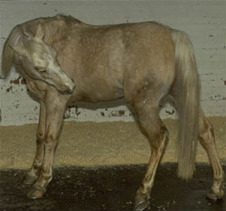 | 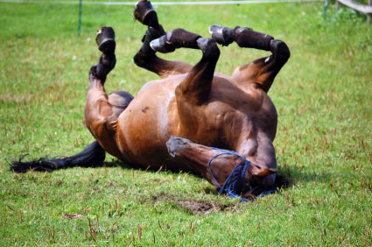

Colic (cont.)

There can be many causes of colic and some horses may seem to have a predisposition for it or get colic more often than others. Some of these causes include teeth defects, worm infestations, ingestion of sand, ingestion of straw, sudden changes in diet, lush grazing, large intakes of water whilst hot, stress, feeding too soon after exercise.
The first step in managing a horse with colic is to contact your veterinarian. Once you have sought veterinary help, you can supervise the horse while waiting for help to arrive. Remove all objects that the horse could potential injure itself on from the area (i.e., feed bins, buckets). The horse’s behaviour may be particularly violent in severe situations so it is important to remember not to put your self in harms way. Try to keep the horse from rolling, where the horse is less violent in its behaviour the horse can be walked gently for a few minutes at a time and allowed to lie quietly. During this time vital signs should be monitored and note any urination, defecation or passing of wind.
The treatment a horse requires will depend on the type of colic it has and the severity. A positive thought however is that 80% of colics are benign and horses often improve with short gentle walking whilst waiting for the vet.

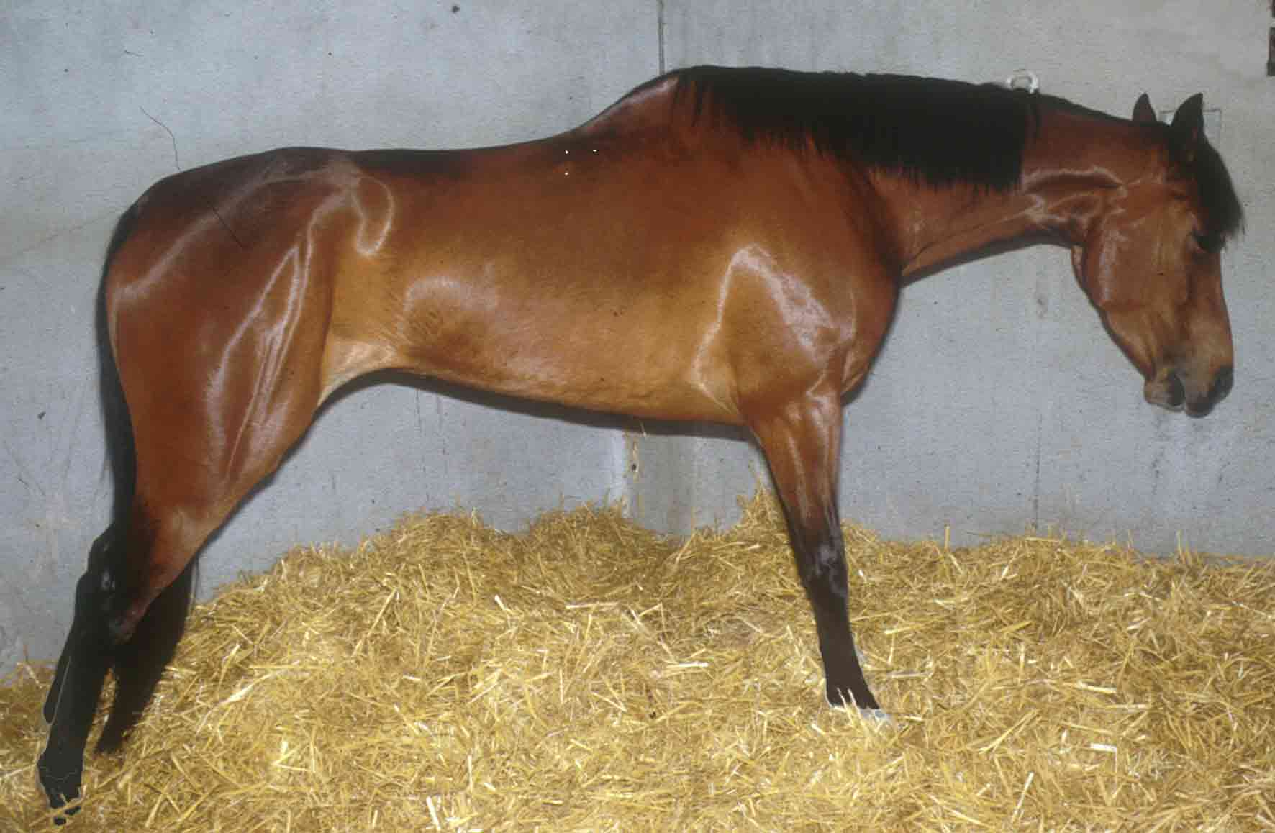

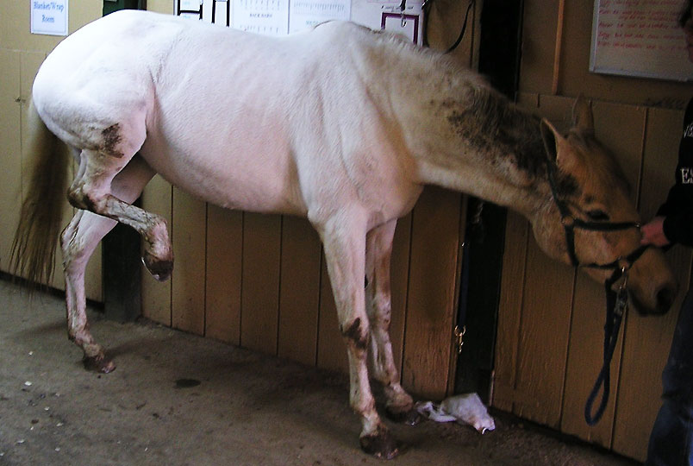

Botulism

Botulism is caused by a spore forming bacterium (Clostridium botulinum) which reproduces in decaying plant or animal matter and in the right conditions (warmth and humidity) produce a lethal toxin. Most commonly this toxin is ingested by horses where the bacterium has been inhabiting silage or vacuum packed hay (moist).
Young foals with botulism exhibit dilated pupils, impaired suckling, inability to swallow, muscular weakness, muscular tremors, collapse and inability to rise. In adult horses the motor nerves and respiratory systems are affected with muscle tremors over the shoulders and flanks, weak shuffling gait, unco-ordination, difficulties with mastication and swallowing. Motor problems can be mild or so severe that there is almost total paralysis of the voluntary and involuntary musculature system. This is a very serious disease that can result in death from respiratory paralysis.
Prevention is better than cure, especially in the case of this disease as severe cases usually result in death. A botulism anti-toxin is available in the U.S.

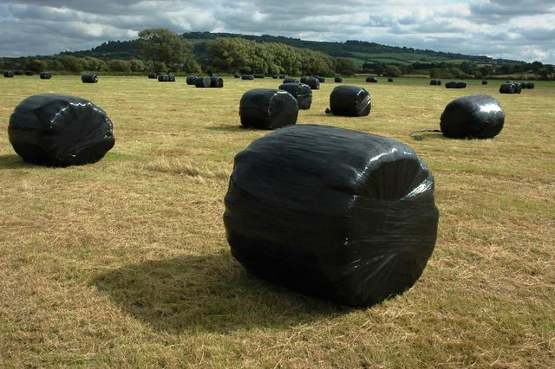 | Left: Bales of silage. Silage is fodder that has been wrapped in plastic to eliminate air exposure. Whilst in the plastic the fodder goes through a fermentation process however if the bag is punctured or if dead animals are baled within the plastic secondary fermentation occurs and this is how the bacteria come to exist and produce the toxin.

Enteritis

Enteritis is the inflammation of the intestines. This inflammation is caused by irritation to the intestine wall and is associated with diarrhoea which is usually the first sign. The causes of enteritis are many such as bacterial and viral infections, worm infestations, access to an abundance of fresh, green grass and overfeeding of high protein foods. Horses do not have the ability to vomit so the body must look for other ways to attempt to be rid of the cause of inflammation.
Depending on the severity manure can varying from loose dropping to cow pat consistency and in severe cases brown water.
Once the cause of the irritation is identified the relevant course of action can be applied. A sample of manure can be taken for analysis for bacteria, viruses or parasites. Diarrhoea related to feed problems can usually be rectified in removal or correction of the suspected cause. If diarrhoea is severe or continues for longer than 24 hours veterinary attention should be sought. In severe cases it may be necessary for the horse to receive fluids intravenously to counteract dehydration.

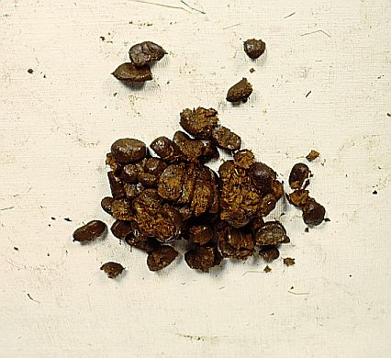 | 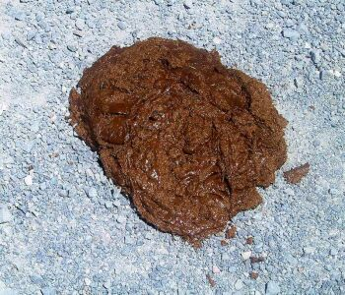
Horse manure of normal consistency. | Horse manure that suggests the horse has diarrhoea.

Colitis X

This condition is similar to that of enteritis in that it involves intestinal disturbance and diarrhoea except that its onset is usually associated with stress (e.g., surgery, transport) or some forms of antibiotics and predominately results in death. A definite cause for colitis x is yet to be determined.
The first sign is usually severe depression with sudden onset of profuse, watery diarrhoea followed by a high temperature, dehydration, discolouration of the mucous membranes, rapid heart rate, cold extremities leading to hypovolemic (decreased blood volume) shock.
Most treatments for colitis x are ineffective, with the disease progressing rapidly before help can arrive. Death can occur as soon as within 3 hours of the onset of symptoms.

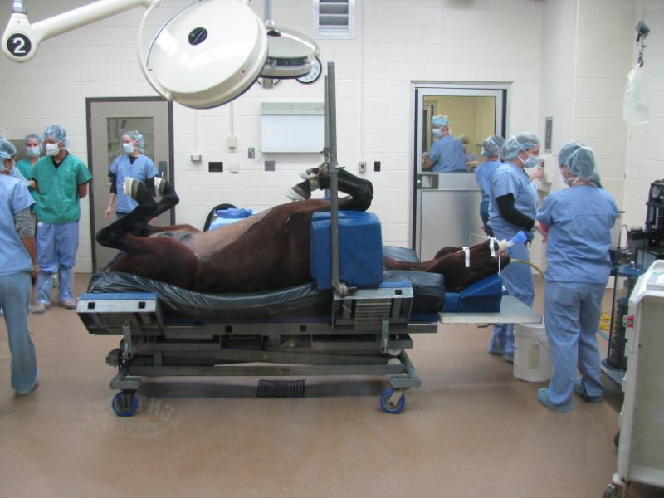

Extension Lesson

Identify the cause, symptom and treatment of the following ailments.
Botulism | Cause: | Symptoms: | Treatment:
Colic | Cause: | Symptoms: | Treatment:
Enteritis | Cause: | Symptoms: | Treatment:
Colitis X | Cause: | Symptoms: | Treatment:

Recommended Reading

Publication:- Author:-
Veterinary notes for horse owners Captain M. Horace Hayes
The BHS veterinary manual P. Stewart Hastie

Websites:-
http://www.omafra.gov.on.ca/english/livestock/horses/facts/info_botulism.htm
http://www.dpi.qld.gov.au/4790_19850.htm
http://www.merckvetmanual.com/mvm/index.jsp?cfile=htm/bc/22206.htm
http://www.petmd.com/horse/conditions/digestive/c_hr_colitis?page=2#.T3UmANneuSo

References

Publication:- Author:-
Veterinary notes for horse owners Captain M. Horace Hayes
The BHS veterinary manual P. Stewart Hastie
6th Edition Pony Club Manual No.2 Elaine Knox-Thompson & Suzanne Dickens
Common Health Problems of Horses John Kohnke

Websites & Images:-
commons.wikimedia.org
www.omafra.gov.on.ca
www.dpi.qld.gov.au
www.merckvetmanual.com
www.petmd.com

