

Student Workbook

3.T.09 Coaching Practices

Student Name: ……………………………………………………………

Student Number: ………………………………………………………….

Email: ………………………………………………………………………

Phone: ……………………………………………………………………..

Other Personal Information

www.OnlineHorseCollege.com
(Ausintec Academy P/L ATF Ausintec Academy Trust T/as)
Ausintec Academy

Mailing Address:-
392 Bribie Island Road,
CABOOLTURE QLD 4510
(between Brisbane & Sunshine Coast)
AUSTRALIA
Registered Training Organisation No:31352
Centrelink Approval No: 4P530
CRICOS Provider Code: Pending

Phone within Australia (07) 3102 5498
Outside Australia + 61 7 3102 5498
Request@OnlineHorseCollege.com

Contents

Unit Information Pg. 4
Introduction Pg. 6
Coaches Code of Conduct Pg. 7 & 8
General Code of Conduct Pg. 9
Anti-Doping Pg. 10
Ethical Responsibilities Pg. 11
Natural Justice Pg. 12
Professional Development Pg. 13
Occupational Health & Safety Pg. 14
Coaching Styles Pg. 15
Extension Lesson Pg. 16
Recommended Reading Pg. 17
References Pg. 18

Coaching Practices 3.T.09 Workbook

Students are to complete Riding 3.R online assessments prior to attempting Teaching 3.T and to follow all recommended safety considerations.

Practical assessments for Teaching 3.T.09-12 are as follows:

- Coaching Practices

- Coaching Special Groups

- Provide First Aid

- First Aid Scenario

These assessments incorporate the following unit from the SIS30710 Sport Industry Training Package which include the listed elements

SISSCGP201A Apply legal and ethical coaching practices

- Apply legal responsibilities to coaching

- Apply ethical responsibilities to coaching or instruction

- Develop coaching practices

SISSCGP306A Customise coaching for special needs groups

- Consult with athletes to determine special needs

- Plan coaching session to include special needs groups

- Deliver coaching session to include special needs groups

- Evaluate coaching session

HLTFA301B Apply first aid

- Assess the situation

- Apply first aid procedures

- Communicate details of the incident

- Evaluate own performance

Further information about this assessment is available at www.training.gov.au

Coaching Practices Introduction

Your role as a coach will require you to ‘wear many hats’, figuratively speaking, you may be required to be a motivator, planner, advisor, fundraiser just to name a few.
Athletes have a right to confidentiality, which means any athlete information must not be passed on to anyone else without the athlete’s consent.

Coaches Code of Conduct

- Promote the welfare of the horse as the primary consideration following the principles of the FEI Code of Conduct for the welfare of the Horse.

- Ensure that equipment and facilities meet safety standards and are appropriate to the age and experience of the horse and the rider.

- Respect the talent and commitment of each rider and their horse and seek to develop their potential.

- Treat each rider and horse as a unique individual.

- Respect fellow coaches and their pupils and encourage riders to do likewise.

- Learn as much as possible about the sport, keep up to date with developments.

- Make sure that the time spent with you is positive and self-enhancing for the rider.

- Never deceive or mislead the rider.

- Be dignified and controlled and teach the riders to be likewise.

- Actively discourage the use of drugs prohibited by the ASC, the EFA and the FEI.

- Discourage the use of cruel or injurious training methods and set a good example with your own training methods.

- Teach the rider that the rules of the sport are mutual agreements which no one
should evade or break. It is the duty of the coach to know and abide by the EFA and the FEI rule and to encourage compliance in spirit and in deed.

- Respect the judgement of officials and encourage riders to do likewise.

- Avoid over facing horses and riders.

- All pupils are entitled to and deserve equal time in group lessons.

- Follow the advise of medical and veterinary practitioners when dealing with injured horses and riders.

- When coaching young rides make only reasonable demands on their time, energy and enthusiasm.

- Always consider the maturity level of the child.

- Refrain from any form of personal abuse towards your riders.

- Refrain from any form of harassment towards your riders.

Coaches Code of Conduct (cont.)

- Any physical contact with your riders should be:
- Appropriate to the situation
- Necessary for the rider’s skill development

- Understand the repercussions if you breach or are aware of any breaches of this Member Protection Policy.

The code of conduct may vary slightly for your area and between different sports. It generates a standard for coach behaviour and is a reference for what the public can expect the coach’s behaviour to demonstrate.

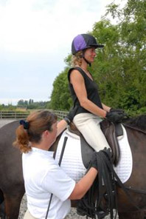

General Code of Conduct

Within Australia, members of the Equestrian Federation of Australia (EFA) are require to comply with the following general code of conduct when attending activities conducted by the EFA or its affiliates.
- Respect the rights, dignity and worth of others.

- Be fair, considerate and honest in all dealing with others.

- Be professional in, and accept responsibility for, your actions.

- Make a commitment to providing quality service.

- Be aware of, and maintain an uncompromising adhesion to the EFA standards, rules, regulations and policies.

- Scrupulously avoid any conduct using privileged information to gain a personal or commercial advantage.

- Operate within the rules of the sport including national and international guidelines which govern Equestrian Sport, the member associations and the affiliated clubs.

- Do not use your involvement with the EFA, its member associations or affiliated clubs to promote your own beliefs, behaviours or practices where these are inconsistent with those of the EFA.

- Demonstrate a high degree of individual responsibility especially when dealing with persons under 18 years of age, as your words and actions are an example.

- Avoid unaccompanied and unobserved activities with persons under 18 years of age, wherever possible.

- Refrain from any form of harassment of others.

- Refrain from any behaviour that may bring the EFA, its member associations or affiliated clubs into disrepute.

- Provide a safe environment for the conduct of the activity.

- Show concern and caution towards others who may be sick or injured.

- Be a positive role model.

- Understand the repercussions if you breach, or are aware of any breaches of the EFA Member Protection Policy.

Though these rules aren’t bound world wide they are a good example of how a coach should conduct themselves and their behaviour when involved within the horse industry.

Anti-Doping

Doping is defined as being the occurrence of one or more of the anti-doping rule violations that are set forth within anti-doping rules. Within the equine industry there are anti-doping rules for humans and equines. As a coach, part of your role is to actively discourage the use of prohibited substances.
Detailed descriptions of anti-doping policies can be found at the World Anti-Doping Agency website (www.wada-ama.org) whilst the equine policy can be found at the Federation of Equestre Internationale (FEI) website (www.fei.org).
On the FEI site you will also find a list of equine prohibited substances.
The prohibited substances document describes such as being:-
Agents, cocktails or mixtures of substances that may affect the performance of a horse;
masking agents; substances with no generally accepted medical use in competition horses;
substances which are usually products prescribed for use in humans or other species; agents used to hyper-sensitise or desensitise the limbs or body parts.

Agents which could influence performance by relieving pain, sedating, stimulating or
producing/modifying other physiological or behavioural effects.

Substances that either have limited performance enhancing potential or to which horses
may have been accidentally exposed, including certain dietary contaminants.



Ethical Responsibilities

This refers to the behavioural in which a coach interacts with athletes or conducts a coaching program.

A coach has a duty of care to the athlete, this means that the coach will provide reasonable care to the athlete.
Because of this, the coach has legal responsibilities to:-

- Provide a safe environment and facilities for athletes and others involved in the activity. This includes the consideration of weather conditions.

- Plan activities adequately. Use appropriate progression when teaching skills.

- Evaluate athletes for injuries or incapacities. Account for individual differences and athletes should never be forced to participate in an activity they don’t want to.

- Young athletes shouldn’t be mismatched. Match young participants according to age, weight, maturity and height with consideration given to experience and skill level.

- Provide safe and proper equipment. Keep equipment in good working order.

- Inform athletes of inherent risks associated to the sport. Participants can only, legally accept any risks if they know about them.

- Supervise activities closely. Supervision is necessary to ensure a safe environment.

- Know first aid. Coaches need to have knowledge of basic first aid principles.

- Develop clear, written rules for general and session conduct. To minimise injuries around session venues.

- Keep accurate records. These are useful for planning and a legal requirement for injuries.

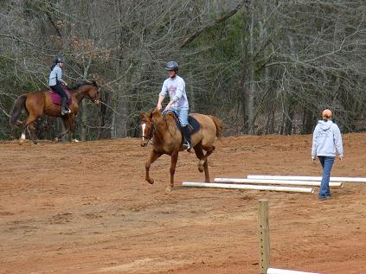
Natural Justice

This is a legal philosophy used in the determination of just or fair processes. It operates on the principles that you should treat others as you would like to be treated.
It includes the notion of fairness and can incorporate the following:-
- a right to advanced warning or a notice of change
- the right to an explanation
- those making decisions act without bias
- proceedings should be fair to all parties
- the right to appeal
- the right to be heard
- decision makers should ignore irrelevant considerations
- personal interest in proceedings should be declared



Professional Development

Staying Up-to-Date
Part of your role as a coach is to keep informed with developments within the sport. The Federation of Equestre Internationale (FEI) has information at an international level of horse sports.
Within Australia there is the Equestrian Australia (EA formerly the EFA) which has branches for each state and provides information at a national and state level of horse sports.
You will need to have knowledge of current rules, equipment and training resources to provide athletes with relevant and current training.
As a coach, sooner or later you may need to attend clinics or seminars to maintain a ‘current’ or ‘active’ status with relevant coaching bodies. This helps to ensure coaches keep up with a general standard within the industry.

Advancing your Sport
You can assist in keeping your sport flourishing within the industry by getting involved outside of the coaching environment.
For example getting involved at events and competitions by working with or as an official and working with other coaches, judges and sports specialists.
Not only will it help to advance the sport but may also provide opportunities to stay up-to –date with developments.

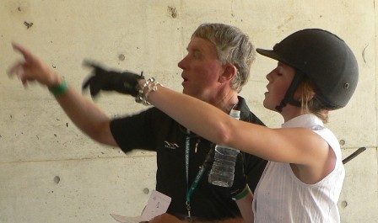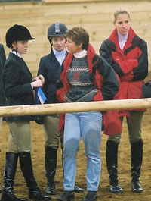
Occupational Health & Safety

Occupational health and safety acts are legislation which set out requirements to keep workplaces safe and healthy. It applies to all those who are involved within the activity for example, volunteers and coaches (including free-lance coaches).
The acts will include requirements for:-
- prevention of industrial injuries and diseases

- maximum recovery and rehabilitation from incapacity of injured workers

- promoting occupational health and safety in the workplace

- protecting the health and safety of the public regarding work activities

- promoting occupational health and safety in the workplace

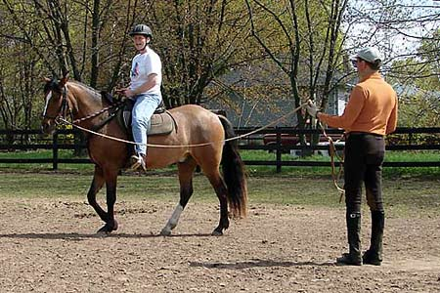

Coaching Styles

There are advantages and disadvantages to all styles of coaching but all of them can be successful. There are five different styles identified here, however coaches may need to adapt to different styles in different situations and circumstances. Athletes will quickly notice a coach’s, coaching style and this may be a help or a hindrance.
‘Easy going’ coach  The ‘easy going’ coach is one who is casual or submissive | Advantages:- Works well with young children
 | Disadvantages:- Can give the impression of not being serious
Authoritarian coach  This coach is very strict and has the personality to handle being hated in order to have respect | Advantages:- Could improve structure or discipline to the lazy or undisciplined athlete. Can give clear, precise direction regarding non-negotiable issues (i.e. safety)
 | Disadvantages:- Punishes frequently and when the athlete is winning will have good spirit but doesn’t last if losing
Business-like coach  Coaches keen on seeing the job done and expects 100% all the time | Advantages:- Organised, efficient and structured
 | Disadvantages:- Not very people orientated however their organised approach towards getting the job done assists in organising other people.
Intense coach  A coach focused on the quality of performance and results | Advantages:- Improves quality of performances
 | Disadvantages:- Can easily transmit anxiety through an ‘uptight’ attitude
‘Nice guy’ coach  Gets on well with those who are likely to be self disciplined and have simular temperament | Advantages:- Good with young, timid children. Motivational and encouraging especially towards reaching goals.
 | Disadvantages:- Sometimes the personable and co-operative nature of this coach can be taken advantage of.
Whilst your coaching style may not necessarily be one or another of the above styles, it will be important to be able to adapt and incorporate these into your style at certain times.
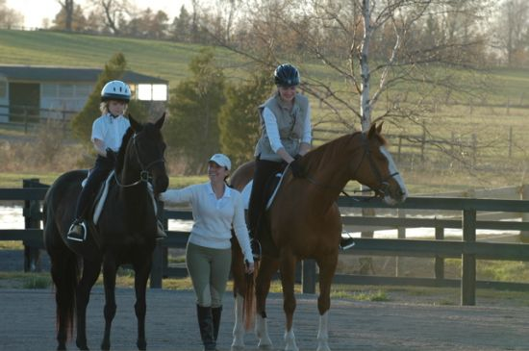
Extension Lesson

Do some research with your local, state or even international horse sport bodies into any rules amendments relevant to your sport. Note any changes below.

……………………………………………………………………………………………………….

……………………………………………………………………………………………………….

……………………………………………………………………………………………………….

………………………………………………………………………………………………………..

Visit the World Anti-Doping Agency website (www.wada-ama.org) and locate and read the following items.

- Anti-doping codes
- Prohibited substance list
- Resources for athletes

Visit the Federation of Equestre Internationale (www.fei.org) and locate and read the following items.

- Medication control and anti-doping for athletes
- Medication control and anti-doping for horses
- The FEI code of conduct for the welfare of the horse

Recommended Reading

Webpages:-

FEI Horse Welfare
http://www.fei.org/FEI/FEI_Organisation/Profile/Pages/Code_of_Conduct.aspx

FEI Medication Control and Anti-doping for Athletes
http://www.fei.org/Athletes_AND_Horses/Medication_Control_AND_Antidoping/Athletes/Pages/Information.aspx

http://www.wada-ama.org/rtecontent/document/code_v2009_En.pdf

FEI Medication Control and Anti-doping for Horses
http://www.fei.org/ATHLETES_AND_HORSES/MEDICATION_CONTROL_AND_ANTIDOPING/HORSES/Pages/Information.aspx

http://www.fei.org/Athletes_AND_Horses/Medication_Control_AND_Antidoping/Horses/Documents/Annex%20III%20-%20Equine%20Prohibited%20List.pdf

http://www.fei.org/Athletes_AND_Horses/Medication_Control_AND_Antidoping/Horses/Documents/EADMC%20Rules%20-%201st%20edition,%20updated%2010%20April%202008.pdf

WADA Code
http://www.wada-ama.org/rtecontent/document/code_v2009_En.pdf

Prohibited Substances
http://www.wada-ama.org/rtecontent/document/code_v2009_En.pdf

References

Publication:- Author:-

Beginning Coaching Level 1 Manual Australian Sports Commission

Websites:-

www.fei.og

www.wada-ama.org

www.ausport.gov.au

http://en.wikipedia.org/wiki/Natural_justice

Images:-

Page 8 | www.rideinbalance.co.uk/lunge-lesson.html
Page 10 | www.quotientbioscience.com/content/timeline
Page 11 | www.countryspringsequestriancenter.com/
Page 12 | mises.org/story/2426
Page 13 | www.cmsport.co.nz/notice-board/217
Page 13
  www.equisearch.com/.../loricramer_111004/
Page 14 | www.equinepositivelearning.co.nz/
Page 15 | www.equinenow.com/farm/hockley_hills_school_o..

