

Student Workbook

3.R.21 Prepare for Lunging

Student Name: ……………………………………………………………

Student Number: ………………………………………………………….

Email: ………………………………………………………………………

Phone: ……………………………………………………………………..

Other Personal Information

www.OnlineHorseCollege.com
(Ausintec Academy P/L ATF Ausintec Academy Trust T/as)
Ausintec Academy

Mailing Address:-
392 Bribie Island Road,
CABOOLTURE QLD 4510
(between Brisbane & Sunshine Coast)
AUSTRALIA
Registered Training Organisation No:31352
Centrelink Approval No: 4P530
CRICOS Provider Code: Pending

Phone within Australia (07) 3102 5498
Outside Australia + 61 7 3102 5498
Request@OnlineHorseCollege.com

Contents

Unit Information Pg. 4

Prepare for Lunging Introduction Pg. 5

Equipment Pg. 6 - 8

Lunging Areas Pg. 9

Suitable Horses for Lunging Pg. 10 & 11

Extension Lesson Pg. 12

Recommended Reading Pg. 13

References Pg. 14

Prepare for Lunging 3.R.21 Assessment Information

Students are to complete Riding 3.R.01–04 online assessments prior to attempting Riding 3.R.21-24 and to follow all recommended safety considerations.

Practical assessments for Riding 3.R.21-24 are as follows:

- Prepare for Lunging

- Lunging the Horse

- Lunging the Rider: Mounting & Dismounting

- Lunging the Rider: Walk, Trot & Canter

These assessments incorporate the following unit from the SIS30710 Sport Industry Training Package which include the listed elements

SISSEQS303A Teach the fundamental skills of riding

- Plan fundamental riding sessions

- Brief participants

- Conduct riding sessions

- Complete post-session responsibilities

Further information about this assessment is available at www.training.gov.au

Prepare for Lunging Introduction

This workbook begins at the basics with describing the equipment which will be needed to lunge a horse as well as a guide in how to fit these items of gear. Also included is a chapter which describes the type of horse which will be better suited to working on the lunge with a rider.

Equipment

Equipment has been discussed in earlier workbooks but now the focus is directed towards specific lunging equipment and considerations when using this equipment when lunging a horse and rider.

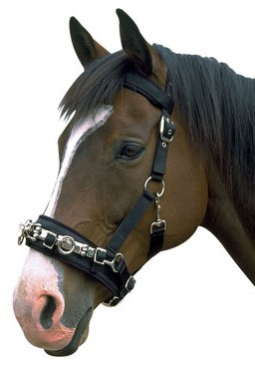 | Cavesson  A lunging cavesson is very simular in structure to a halter except that it has rings for attaching the lunge rein to across the nose and that it when fitted it is adjusted to fit firmly. They can also be used with the bridle.  Fit:- The noseband should sit up the horses’ nose across the bony part (not towards the nostrils). It needs to be fitted firmly so that it doesn’t twist across the horses’ head and rub the eye. This can be tested manually if you can twist it by hand then it needs to be adjusted. The headpiece of the cavesson is fitted over the bridle and the jowl strap and noseband of the cavesson is fitted so that it lies under the cheek straps of the bridle. The noseband should be positioned so that it lies well clear of the breathing passageways (soft section above the nostrils). The jowl strap needs to be fitted firmly so that the cavesson doesn’t pull sideways into the horse’s eye.
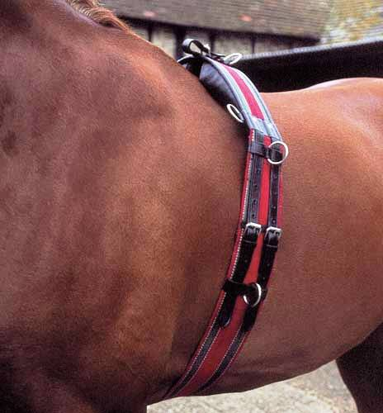 | Roller  These fit around the horse, simular to a girth and allow for equipment such as side reins to be attached to the ‘D’ rings on the roller. They can be used with or without a saddle (must be removed before a rider gets on) and are useful for training on the lunge or warming the horse up in a round outline before the rider mounts.  Fit:- When used without a saddle the roller is placed over a saddle cloth located just behind the withers. Ensure that the padding on the underside of the roller is not pinching or rubbing the spine, this is often an issue with some rollers. It needs to be adjusted to the same tension as the girth to make sure it doesn’t slide backwards or twist. If a roller is used over the saddle during lunging in preparation for a rider the roller must be removed before the rider mounts.

Equipment (cont.)

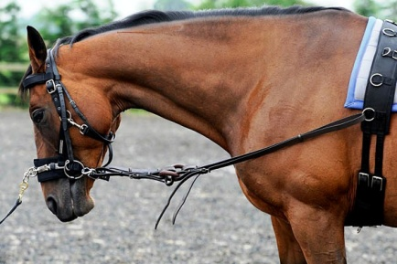 | Side Reins  Side reins influence the horse with contact on the bit and as such work the horse in an outline where it will work over and through the back. They are used to simulate the contact of the riders’ hands. Some contain elastic sections with make them less rigid in the horses’ mouth but some horses may test and stretch the elastic which tends to produce a horse with an unsteady contact.  These can be attached to the roller or to the girth of the saddle (if lunging with a rider, this is covered further in this workbook). Care needs to be taken introducing side reins to horses. Tightening and shortening them too quickly or before the horse is ready to accept that level of contact can results in the horse running backwards, rearing even flipping themselves over.  Fit:- Side reins usually have a clip on one end to attach to the bit and a strap at the other end to fasten it to the roller or girth. This strap also adjusts the length of the side rein. The side reins should be used at a length which reflects the horses’ level/stage of training/education. The higher rings on the roller promote a higher head carriage which horses’ at a lower level of education may find restrictive. The lower rings on the roller allow for a lower head carriage.  The side reins should never be so loose that the horse could become entangled or step on them. The inside side rein should be slightly shorter than the outside rein, this is to position the horse correctly for the direction it is travelling.
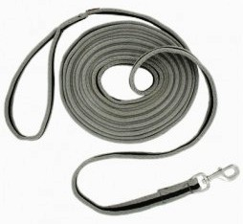 | Lunge Rein  This provides the handler with control over the direction of the horse. Lunge reins or lines can be made of cotton or nylon. Usually about 10 metres in length they attach to the bridle or cavesson by a clip or buckle. The other end of the lunge rein usually has a loop for the handler to hold but for safety reasons it is important to NEVER put your hand through or wrap the lunge rein around your arm, if the horse was to become uncontrollable it is possible that you could sustain injury from being dragged if your arm is wrapped in the lunge rein.  Fit:- This is covered in detail in the next workbook.

Equipment (cont.)

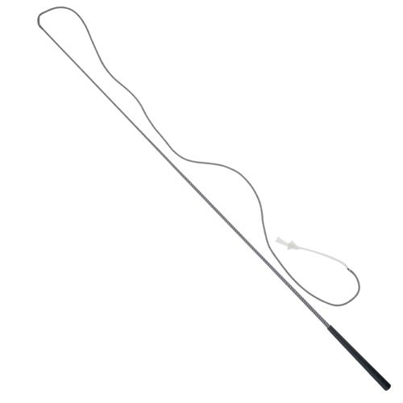 | Lunge Whip  Lunge whips can come in various lengths but it is important that the whip be long enough for the lash to reach the horse on a twenty metre circle  Fit:- The whip you choose to use should be well balanced (not heavy at either end) and easy to hold.
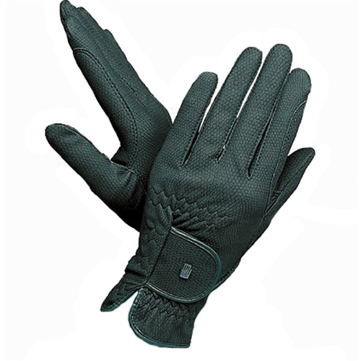 | Gloves  Gloves will protect your hands from rope burn if the horse becomes difficult to handle and will also provide you with better grip on the lunge rein and protection from the sun or cold.  Fit:- Gloves which are too small will make it difficult to close your fingers around the lunge rein and gloves which are too big may become a hinderance.

Lunging Areas

The environment you use to lunge your horse and rider is important to maintain the safety of everyone involved. Areas such as large open paddocks or with uneven ground are unsuitable as they compromise the coaches’ control and will make it difficult for the horse to maintain a consistent rhythm and tempo.
A suitable lunging area should have:-
- strong, safe fencing of at least 1.3m
- level surface
- secure footing (preferably all weather)
- be able to be enclosed (i.e. have a gate)
- free from debris and obstacles
- enough room for a 20m circle (maximum size 20m X 60m, minimum size 18m X 18m)

A suitable lunging area, however the trees to the right of the round yard could prove hazardous to a rider. | 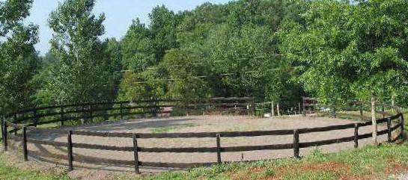

A lunging area should not:-
- be fenced with barbed wire
- have electric fencing
- have fencing rails at a height that the horse may be tempted to jump over or run under
- have broken fencing
- be in an open area
- have jumps set up
- have loose horses in it

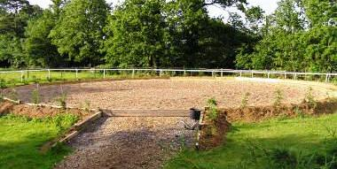 | An unsuitable lunging area. Even though it is well presented, with level and flat ground, it is not enclosed and the design is hazardous in that a horse can step off the edge.

Suitable Horses for Lunging

This section examines the type of horse which would be suitable for lunging a rider. Horses which work well on the lunge will not necessarily be suited to being lunged with a rider.
Quiet horses which are established in their way of going are the best mounts for riders learning on the lunge. This means a horse which is consistent in rhythm and tempo at walk, trot and canter. Ideally a horse which works through the back will be the most desirable however this is not always practical and a horse which has a consistent, natural head carriage (one that does not toss its head, tug on the reins or evade the bit with high head carriage) will take to the role just as well. | 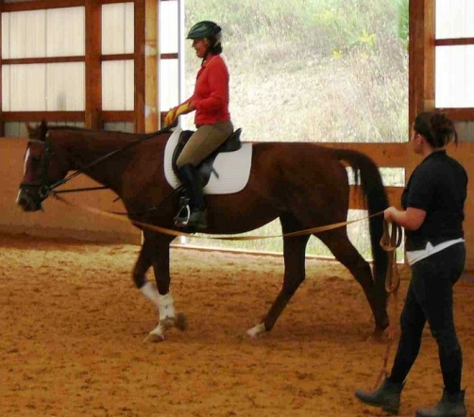

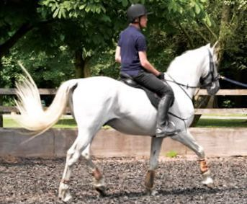 | The horse used for lunging riders should be comfortable to ride. Smooth, even paces to sit on will make the task of learning and improving the seat, balance and strength of the rider much easier for them. Horses with elastic and impulsive (i.e., bouncy) paces can be introduced once the rider has confidence, strength and consistency.

A horse used for lunging a rider needs to be honest in response to the person lunging it. This means if the handler signals for a faster pace the horse should move forward without exuberant behaviour (i.e., bucking, kicking, bolting), the horse also needs to return to the slower paces just as easily, especially in the case of horses used for beginner riders. | 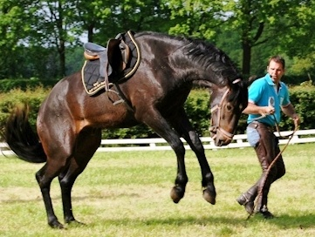

Suitable Horses for Lunging (cont.)

It is likely that the lunging horse, in particular beginner lunging horses, will be exposed to things that experienced, seasoned riders do not do. For example it is common for beginning riders to try to mount or dismount from the wrong side, lean in the saddle, bounce in the saddle, loose stirrups, be tense or excited, squeal, shout, drop the reins and the list goes on. So for safety it is important that the lunge horse be unflappable and patient to common behaviours exhibited by learning riders and learning exercises that may be used for teaching. | 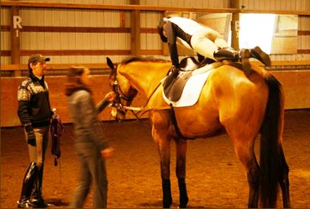

Extension Lesson

Practice fitting the following items of equipment.
- A cavesson to be used on a bridled horse
- A roller and a saddle
- Side reins

Identify 3 horses and describe why they are or are not suitable to be used to lunge a rider.
Horse 1:-………………………………………………………………………………………………
…………………………………………………………………………………………………………….
…………………………………………………………………………………………………………….
…………………………………………………………………………………………………………….
…………………………………………………………………………………………………………….
…………………………………………………………………………………………………………….
Horse 2:- ………………………………………………………………………………………………...
…………………………………………………………………………………………………………….
…………………………………………………………………………………………………………….
…………………………………………………………………………………………………………….
…………………………………………………………………………………………………………….
…………………………………………………………………………………………………………….
Horse 3:- ………………………………………………………………………………………………...
…………………………………………………………………………………………………………….
…………………………………………………………………………………………………………….
…………………………………………………………………………………………………………….
…………………………………………………………………………………………………………….
…………………………………………………………………………………………………………….

Recommended Reading

Publication:- Authors:-
Foot Steps Sally Hinton & Joan Eccleshare

References

Publication:- Authors:-
Foot Steps Sally Hinton & Joan Eccleshare

Images:-
www.examiner.com
www.lucknampark.co.uk
equestrian.cyberhorse.com.au
phoenixinternationale.com
www.sportsnest.com
www.saddlersrow.com

www.OnlineHorseCollege.com
(Ausintec Academy P/L ATF Ausintec Academy Trust T/as)
Ausintec Academy

Mailing Address:-
392 Bribie Island Road,
CABOOLTURE QLD 4510
(between Brisbane & Sunshine Coast)
AUSTRALIA
Registered Training Organisation No:31352
Centrelink Approval No: 4P530
CRICOS Provider Code: Pending

Phone within Australia (07) 3102 5498
Outside Australia + 61 7 3102 5498
Request@OnlineHorseCollege.com

